3. Traffic Signs and devices
3.1 Basic Rules § 1 (StVO)
1. (4P) What should you understand by defensive driving?
- Not insisting on your rights
- Allowing for other people’s mistakes
- Stopping as a precaution at every crossroads
2. (3P) You are driving in a built-up area behind a vehicle with number plates that are not local. What could happen? The driver in front
- could brake unexpectedly
- could stop unexpectedly to ask the way
- may switch on the direction indicators too late before turning
3. (3P) What can cause unnecessary obstructions?
- Stalling the engine in dense traffic
- Vehicles proceeding too slowly for no good reason
- Motor vehicles breaking down because they have run out of fuel
4. (4P) Participation in road traffic requires caution at all times and consideration towards other road users. What döst this mean for you? You must
- drive with foresight
- reckon with improper conduct on the part of others
- insist on your right of priority at all times
5. (4P) What can cause a dangerous situation?
- Cutting Corners
- Dipping your headlights too late
- Driving too far behind the vehicle in front
6. (4P) To which road users must you show particular care?
- To children
- To persons with obvious disabilities
- To taxi drivers
7. (2P) Which of these is a good example of „anticipatory driving“?
- I attempt to identify the intentions of other road users, as soon as possible
- I respond as soon as possible to probable changes in the road traffic situation
- I limit my observation of road traffic as much as possible on the vehicle travelling directly in front of me

3.2 Danger Signs
1. (3P) What must you be prepared for in this situation?
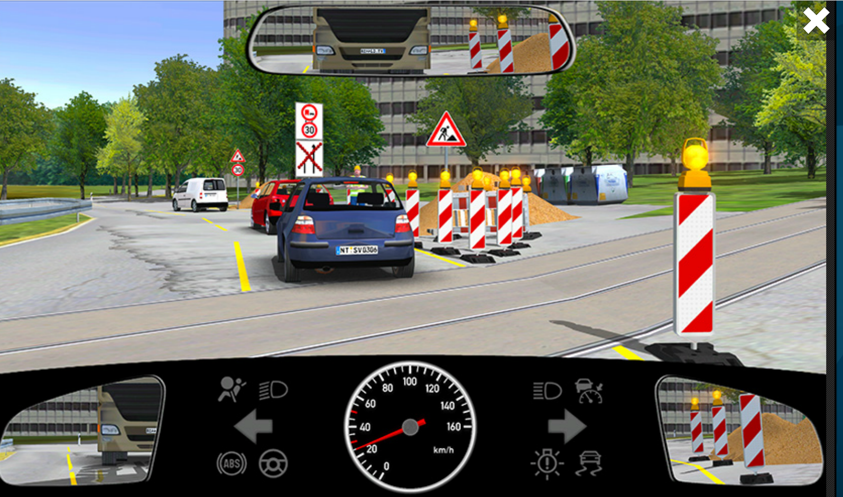
- Workers and construction equipment on the roadway
- An uneven and dirty roadway
- Police regulating traffic
2.  What do you do when you see this traffic sign?
- Reduce Speed
- b) Be ready to brake
- Observe the traffic coming from the right only
3. 
4. 
5.
6. 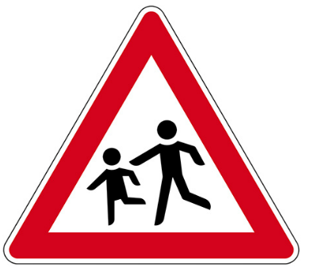
7.
8.
9.
10.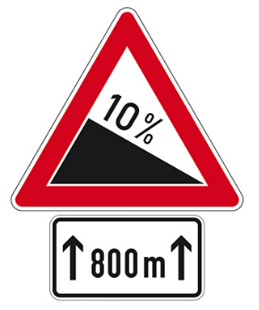
11.
12.
13.
14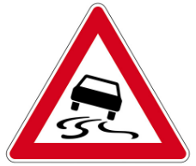
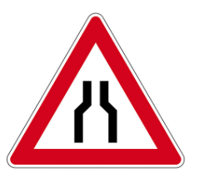
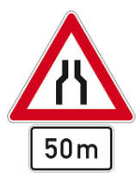

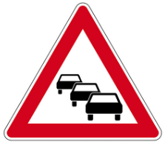

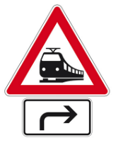



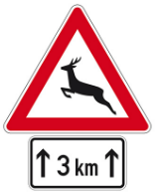
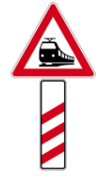


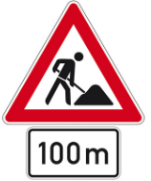
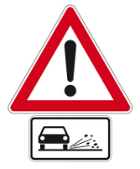

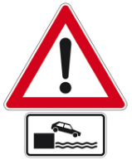

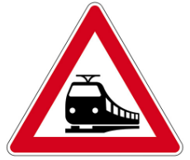
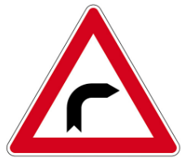
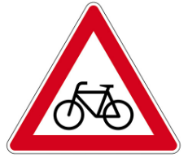




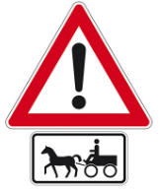
45. How do you pass through an incline safely ? I took my foot off the accelerator completely and

